**DAA Lab-3**

**Name: Nilanshu Ranjan**

**Roll no.: 231070035**

**Branch : Computer Engineering**

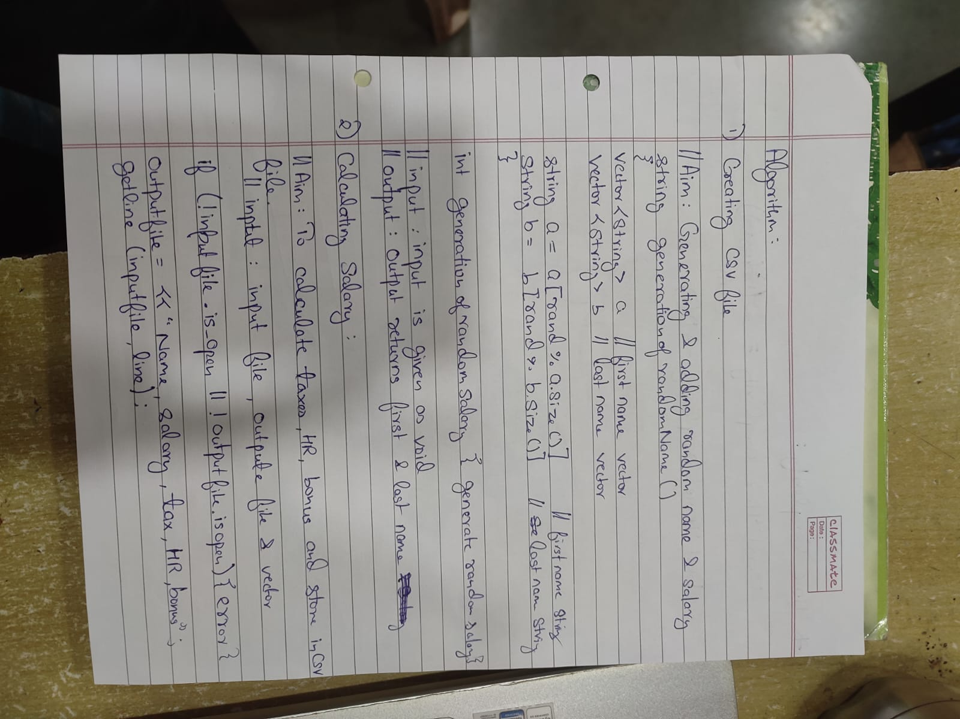

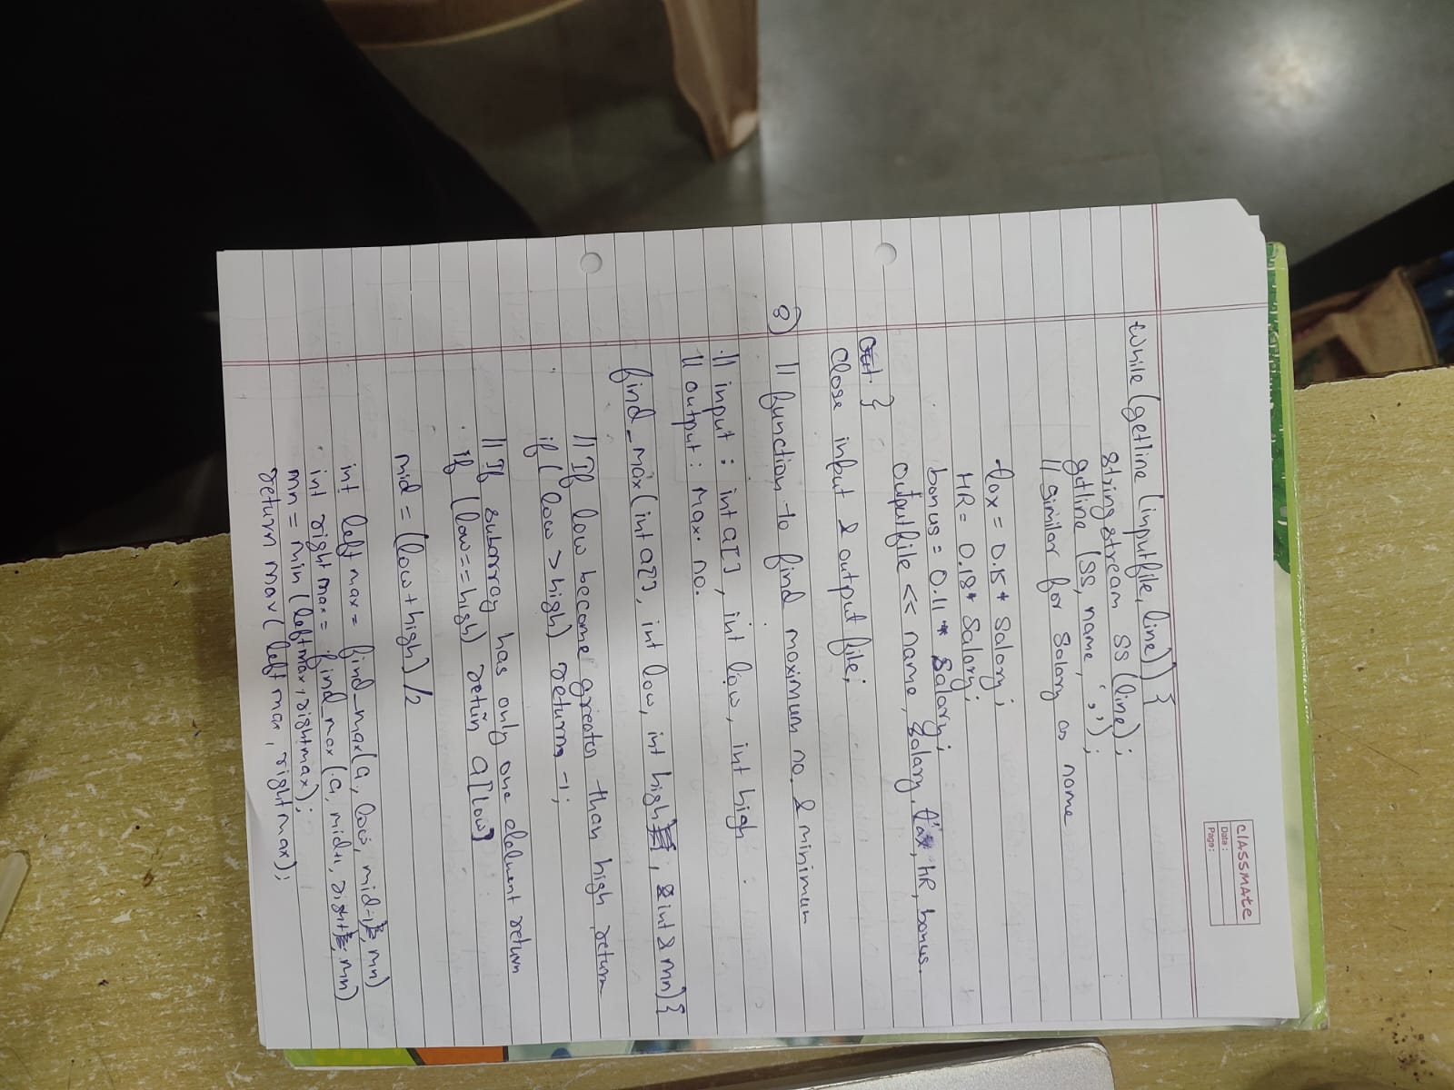

**Test Cases:**

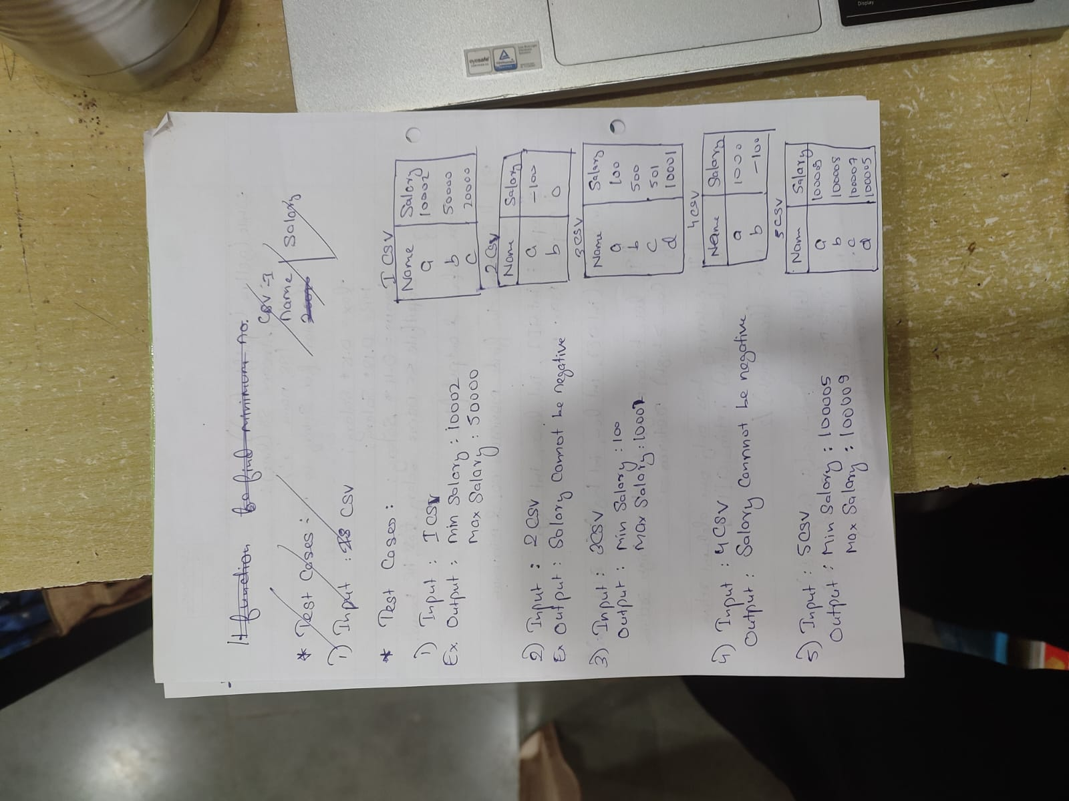

**Code:**

#include <iostream>

 #include <fstream>

 #include <string>

 #include <cstdlib>

 #include <ctime>

 #include <vector>

 using *namespace* std;

 string Generate_Random_Name() {

 vector<string> firstNames = {"John", "Jane", "Alex", "Emily", "Chris", "Katie", "Michael", "Sarah",

"David", "Laura"};

 vector<string> lastNames = {"Smith", "Johnson", "Williams", "Brown", "Jones", "Miller", "Davis",

"Garcia", "Wilson", "Martinez"};

    string firstName = firstNames[rand() % firstNames.size()];

    string lastName = lastNames[rand() % lastNames.size()];

    return firstName + " " + lastName;

 }

*int* Generate_Random_Salary() {

    return rand() % 90001 + 10000; // Random salary between 10,000 and 100,000

 }

*int* main() {

    srand(static_cast<*unsigned* *int*>(time(0))); // Seed for random number generation

    ofstream file("5input.csv");

    if (!file.is_open()) {

        cerr << "Error opening file!" << endl;

        return 1;

    }

    // Write the header

    file << "Name,Salary\n";

    // Generate and write 2000 records

    for (*int* i = 0; i < 2000; ++i) {

        string name = generateRandomName();

*int* salary = generateRandomSalary();

        file << name << "," << salary << "\n";

    }

    file.close();

    cout << "CSV file created successfully!" << endl;

    return 0

 }

#include <iostream>

 #include <fstream>

 #include <string>

 #include <cstdlib>

 #include <ctime>

 #include <vector>

 using *namespace* std;

*int* find_Max(vector<*double*> *a*, *int* *lo*, *int* *hi*)

 {

    if (*lo* > *hi*)

        return -1;

    if (*lo* == *hi*)

        return *a*[*lo*];

*int* mid = (*lo* + *hi*) / 2;

*int* leftMax = findMax(*a*, *lo*, mid);

*int* rightMax = findMax(*a*, mid + 1, *hi*);

    return max(leftMax, rightMax);

 }

*int* find_Min(vector<*double*> *a*, *int* *lo*, *int* *hi*)

 {

    if (*lo* > *hi*)

        return -1 ;

    if (*lo* == *hi*)

        return *a*[*lo*];

*int* mid = (*lo* + *hi*) / 2;

*int* leftMin = findMin(*a*, *lo*, mid);

*int* rightMin = findMin(*a*, mid + 1, *hi*);

    return min(leftMin, rightMin);

 }

*int* main()

 {

 ifstream inputFile("1input.csv"); // Input CSV file

 ofstream outputFile("1.csv");  // Output CSV file

 vector<*double*>v;

 if (!inputFile.is_open() || !outputFile.is_open())

    {

 cout << "Error opening file!" << endl;

    }

 string line;

    // Write the header for the output file

 outputFile << "Name,Salary,Tax,Home Rent,Bonus\n";

    // Skip the header line in the input file

 getline(inputFile, line);

    // Process each line

 while (getline(inputFile, line))

    {

 stringstream ss(line);

 string name, salaryStr;

 getline(ss, name, ',');

 getline(ss, salaryStr, ',');

*double* salary = stod(salaryStr);

 v.push_back(salary);

*double* tax = 0.10 * salary;

*double* homeRent = 0.20 * salary;

*double* bonus = 0.15 * salary;

        // Write the results to the output file

 outputFile << name << "," << salary << "," << tax << "," << homeRent

<< "," << bonus << "\n";

    }

 inputFile.close();

 outputFile.close();

 cout << "Calculations completed and output saved to

'output_finances.csv'." << endl;

 if(findMin(v,0,2000)<0){

 cout<<"Salary can't be negative";

    }

    else{

    cout<<"Min Salary -> "<<findMin(v,1,2000)<<endl;

    cout<<"Max Salary -> "<<findMax(v,1,2000);

    }

    return 0;

 }

**Outputs:**

  Calculations completed and output saved to 'output_finances.csv'.

 Min Salary -> 10008

 Max Salary -> 42755

 PS C:\Users\HP\Desktop\c++>

 Calculations completed and output saved to 'output_finances.csv'.

 Min Salary -> 10019

 Max Salary -> 42715

 PS C:\Users\HP\Desktop\c++>

 Error opening file!

 Calculations completed and output saved to 'output_finances.csv'.

 PS C:\Users\HP\Desktop\c++>

 Calculations completed and output saved to 'output_finances.csv'.

 Min Salary -> 10003

 Max Salary -> 42702

 PS C:\Users\HP\Desktop\c++>

 Calculations completed and output saved to 'output_finances.csv'.

 Salary can't be negative

 PS C:\Users\HP\Desktop\c++

**Conclusion:**

**Code File 1**: Generate_data

This code effectively generates a synthetic dataset of 2000 employee records, simulating a realistic scenario for data analysis. By randomizing names and salaries, it provides a foundation for subsequent data processing and analysis tasks.

**Code File 2**: Process_data

Use divide and conquer algorithm to calculate the maximum and minimum salary of employees from the given data of 2000 employees of a company.

This code demonstrates the ability to efficiently process and analyze the generated employee data. It accurately calculates financial metrics such as tax, home rent, and bonus, and identifies the minimum and maximum salaries within the dataset. The code's output in the form of a CSV file is well-structured and facilitates further analysis or visualization.

Overall, the combined functionality of these code files provides a valuable tool for data analysis and simulation. While the code is generally robust, future enhancements could include more comprehensive error handling, additional data validation checks, and the incorporation of more advanced statistical analysis techniques.